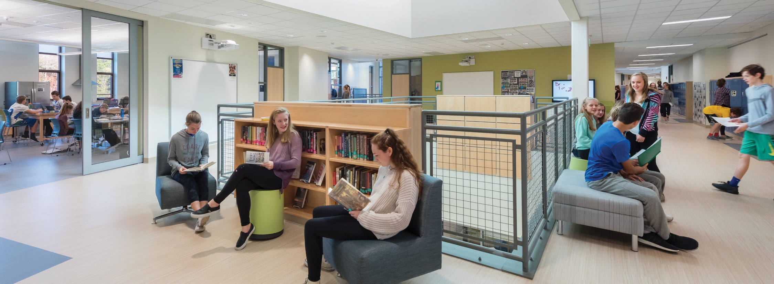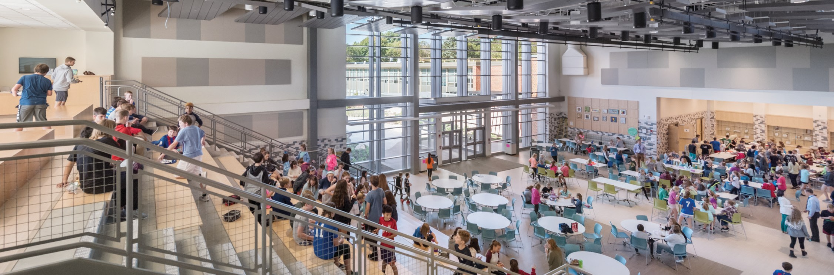

Lester J. Gates Middle School

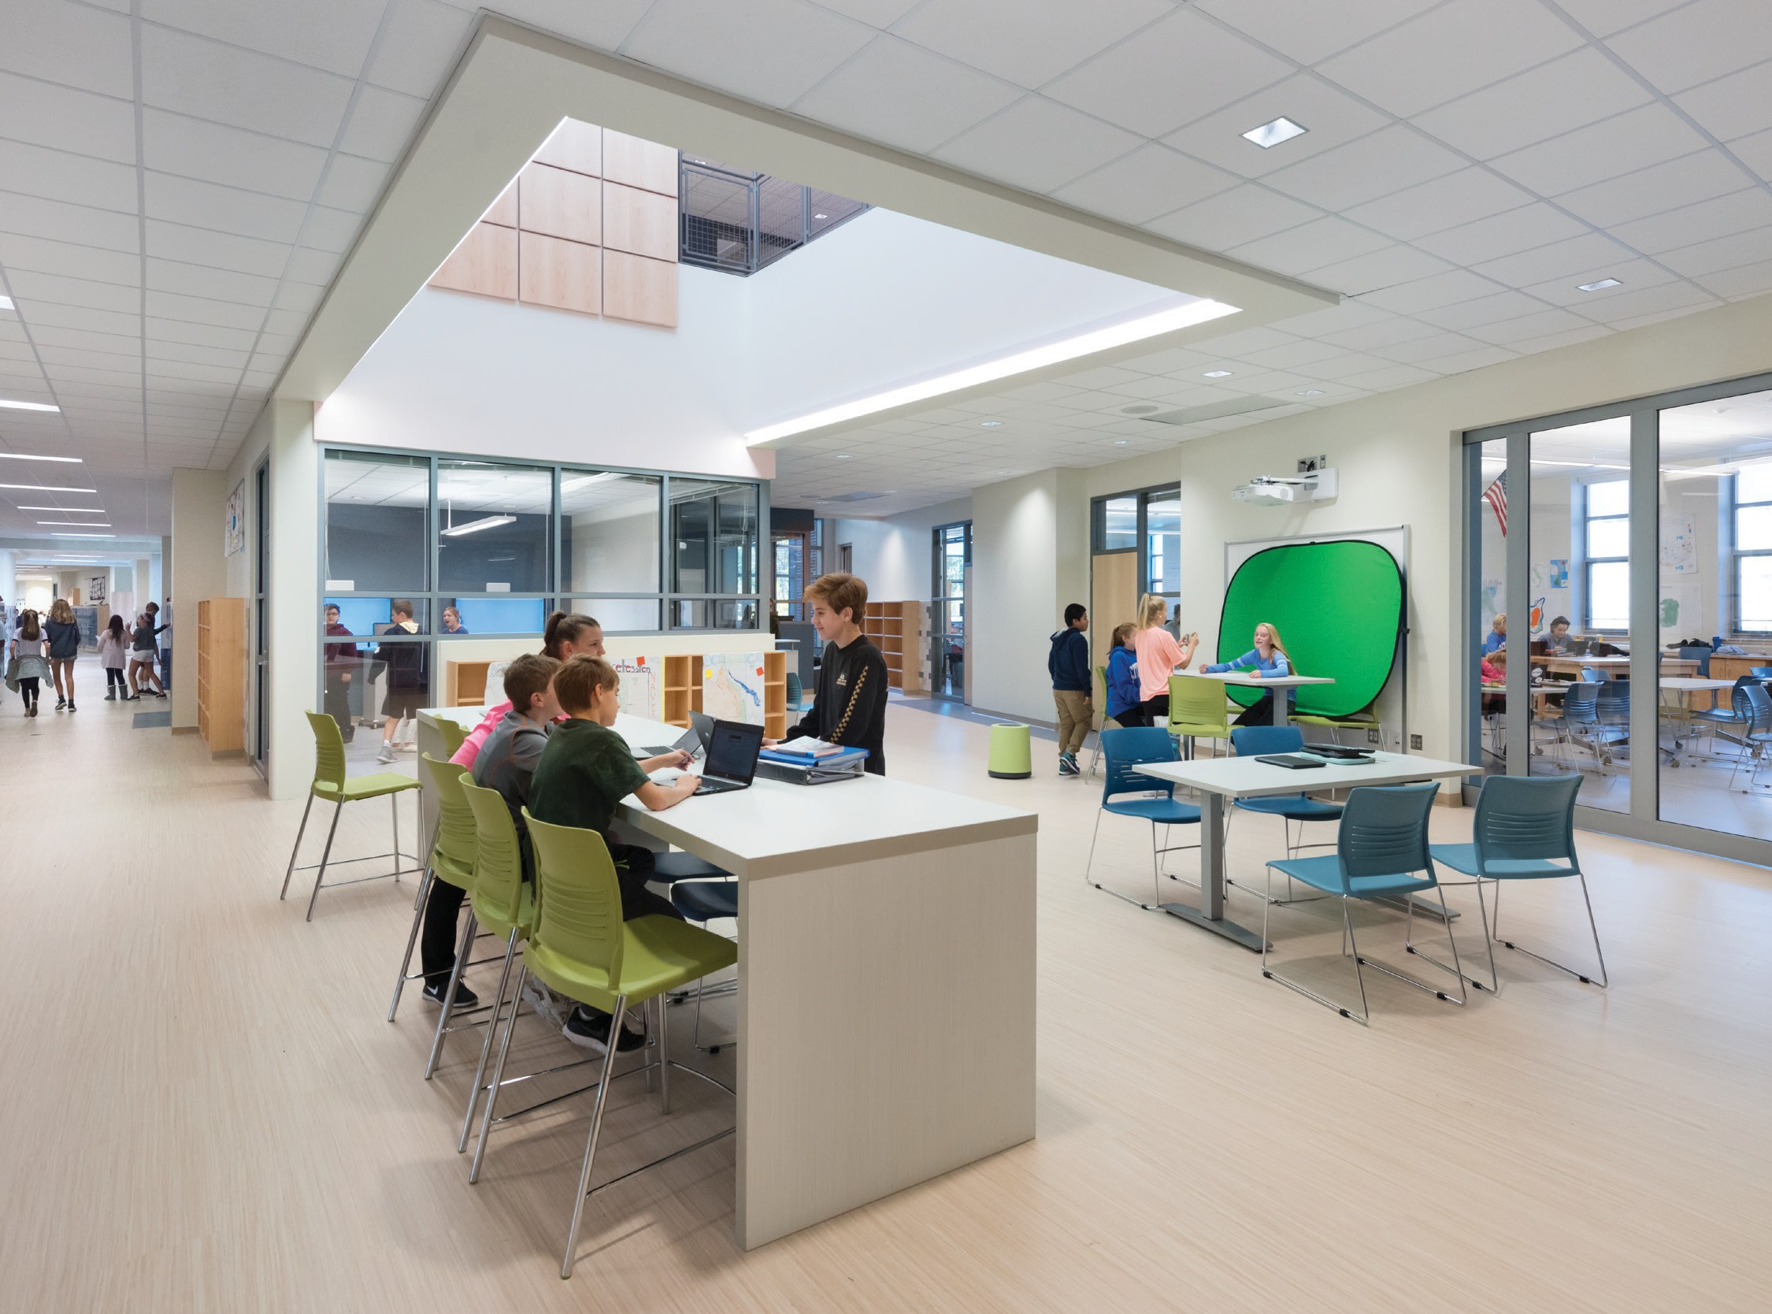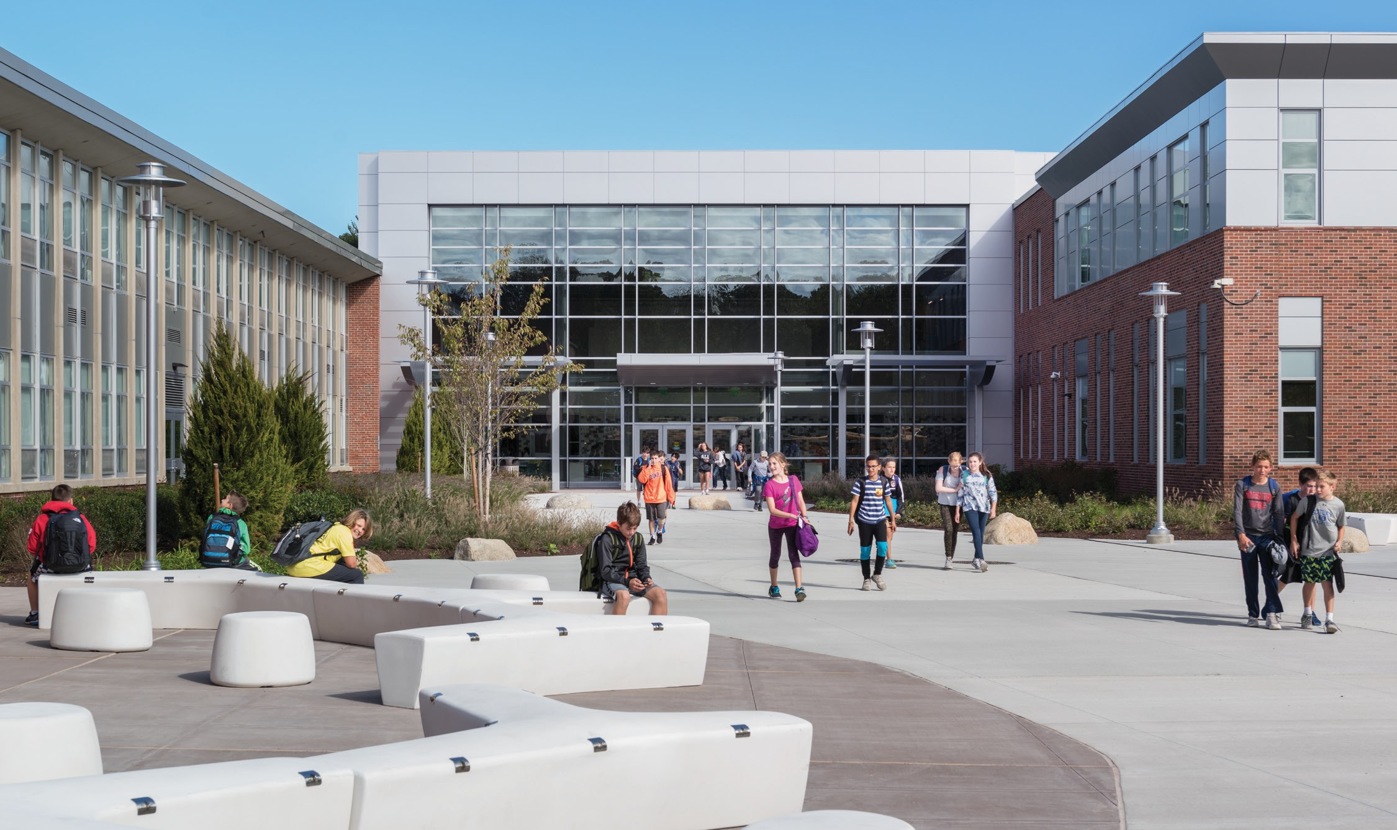

SCITUATE, MASSACHUSETTS

*Support and Enable Project Based Learning*

When Scituate Public Schools embarked on their journey to repair or replace the aging existing intermediate school, there was uncertainty about where that journey would take them. Ultimately, they developed both a new educational vision and a future-ready facility to support that new vision.

[www.doreandwhittier.com](http://www.doreandwhittier.com/)

**CONTROL BOOTH**

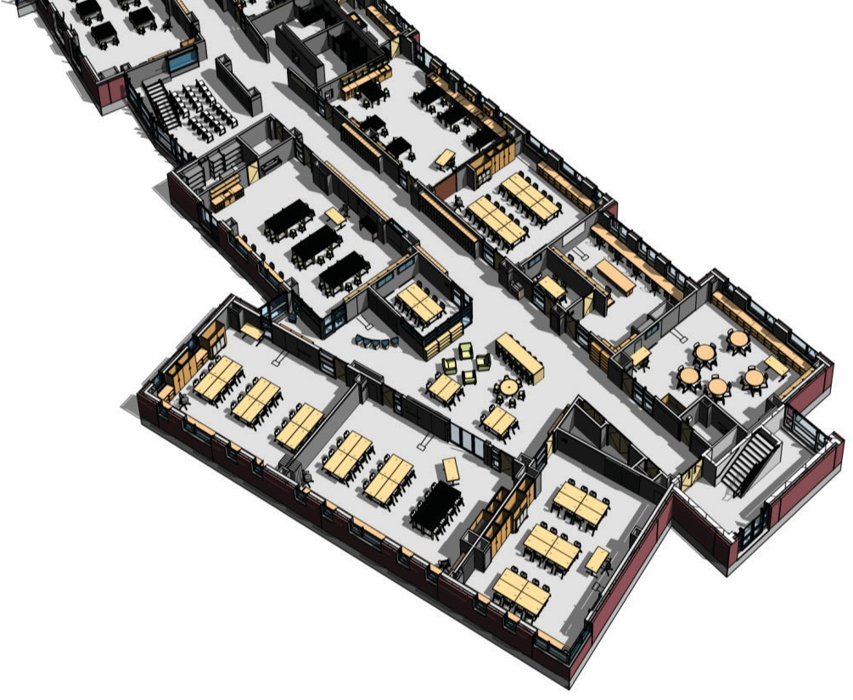

**1180**

LESTER J. GATES

Exhibition

Space

Science Studio

1200 NSF

Learning Studio, Type 4

850 NSF

Teacher Planning

**ELEVATOR CORRIDOR**

**1159 1181**

**CAFE**

**2003**

**899 SF**

**LEARNING**

**STUDIO**

**2033**

**946 SF**

**LEARNING**

**STUDIO**

**2034**

**1108 SF**

**MEDIA COMMONS**

**2029**

**LEARNING**

**STUDIO**

**2037**

**962 SF**

OPEN TO BELOW

**2036**

**ART**

**2035**

**1199 SF**

DN

**Core Academic**

**Special Education**

MIDDLE SCHOOL

Scituate, Massachusetts

**OWNER:**

Scituate Public Schools

**ARCHITECT:**

Dore + Whittier

**CONSTRUCTION FIRM:**

Agostini Bacon Construction

Suite

**CAFE**

**2002**

**705 SF**

**166 SF LITERACY LAB**

**2018**

**EMERGENCY IDF ELECTRIC ELECTRIC 2022 2023**

**2021 62 SF 76 SF**

**50 SF**

OPEN TO BELOW

**CORRIDOR**

**2004**

**1972 SF**

**769 SF**

**STORAGE**

**71 SF**

**STAIR 3**

**S3-2**

**296 SF**

**LEARNING**

**STUDIO**

**LEARNING**

**STUDIO**

**2041**

**971 SF**

**TOILET**

**ELEVATOR 2016**

**1023 56 SF**

**60 SF**

**SMALL GROUP**

**2026**

**JANITOR**

**2028**

**64 SF**

**SCIENCE**

**2030**

**LEARNING**

**STUDIO**

**2032**

**861 SF**

**LEARNING**

**STUDIO**

**2049**

**2047**

**1105 SF**

**TOILET**

**TOILET 2020**

**TOILET RESOURCE 2019 165 SF**

**CORRIDOR RECORDS 2017 165 SF**

DN

**125 SF TEACHER TOILET 1208 SF**

**PLANNING WORK 2027**

**STATIONS 65 SF**

**2024**

**OWNER’S PROJECT MANAGER:**

**953 SF**

**2001**

**1338 SF**

**2015**

**GUIDANCE 2014 61 SF 433 SF**

**WAITING 198 SF**

**2006**

**615 SF**

**SCIENCE PREP**

**2031**

OPEN TO BELOW

**JANITOR**

**EMERGENCY 2038**

**ELECTRIC ELECTRIC 66 SF**

**2040 2039**

**102 SF 73 SF**

**STAIR 2** OPEN TO BELOW

**S2-2**

**295 SF**DN

**100 SF**

**PSYCH OFFICE**

**2007**

**152 SF**

**CONFERENCE**

**2009**

**301 SF**

**CORRIDOR STORAGE**

**2005 2013**

**684 SF 48 SF**

ROOF

**120 SF**

Art Studio

**1213 SF**

**ART STORAGE**

**2052 MEDIA COMMONS**

**148 SF 2050**

**779 SF**

OPEN TO BELOW

**RESOURCE**

**TOILET 2042**

**2044 462 SF**

**ADJUSTMENT**

**OFFICE**

**2008**

**151 SF**

**GUIDANCE**

Daedalus Projects, Inc.

Social/Emotional Classroom

**ART**

**2051**

OPEN TO BELOW

**56 SF**

**GUIDANCE GUIDANCE OFFICE**

**OFFICE OFFICE 2012**

**2010 2011 155 SF** ROOF

**161 SF 151 SF**

1200 NSF

950 NSF

N

**1097 SF**

**LEARNING**

**STUDIO**

**2061**

**956 SF**

OPEN TO BELOW

**DA VINCI**

**2057**

**1508 SF**

OPEN TO BELOW

**TOILET**

**2055**

**208 SF**

**SCIENCE PREP**

**SCIENCE**

**2054**

**1202 SF**

**CORRIDOR**

**2053**

**2297 SF**

**LEARNING**

**STUDIO**

**2048**

**861 SF**

**TEACHER**

**SMALL GROUP PLANNING WORK**

**2045 STATIONS**

**125 SF 2043**

**597 SF**

ROOF

**Art & Music**

**DATE OF COMPLETION:**

**LEARNING**

**STUDIO**

**2063**

**TOILET**

**2056**

**253 SF**

**974 SF**

OPEN TO BELOW

**MEDIA COMMONS**

**2064**

**787 SF**

**CORRIDOR**

**2071**

**2225 SF**

**SCIENCE**

**2058**

**1204 SF**

**2059**

**220 SF**

August 2017

**LEARNING**

**STUDIO**

**2065**

**EMERGENCY**

**ELECTRIC**

**2073**

**66 SF**

**ELECTRIC**

**2072**

**76 SF**

**TOILET**

**SMALL GROUP**

**2066**

**125 SF**

**TEACHER**

**LEARNING**

**STUDIO**

**2062**

**859 SF**

**2069 PLANNING WORK**

**64 SF**

**STATIONS**

**2067**

**596 SF**

**RESOURCE**

**2070**

**463 SF**

Learning Studio, Type 1

950 NSF

SECOND FLOOR PLAN

**STAIR 1**

DN **S1-2**

**387 SF**

ROOF

**VESTIBULE**

**1157**

**Health & Physical**

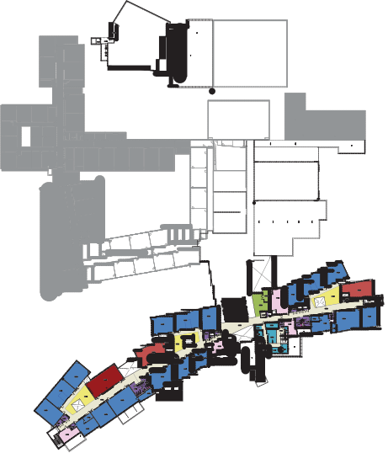

**Education**

**MISSION:**

Transition to a project-based learning approach where teachers and students

are engaged in interdisciplinary, real-world

experiences that promote collaboration,

**237 SF**

**LOBBY**

**1158**

**2262 SF**

**1164**

**STAGE STORAGE**

**1178**

**801 SF**

communication, higher order thinking

**TOILET**

**1160**

**302 SF**

**AUDITORIUM**

**1163**

**7296 SF**

**STAGE**

**2075 SF**

**ESSEMBLE**

**1173**

**166 SF**

**STORAGE**

**1175**

**178 SF**

**TOILET**

**1161**

**296 SF**

**DRESSING**

**1170**

**108 SF**

**DRESSING**

**1169**

**Media Center**

skills, and creative problem solving.

**106 SF**

**EMERGENCY**

**ELECTRIC**

**1166**

**140 SF ELECTRIC**

**1167**

**220 SF**

**CORRIDOR**

**1165**

**2083 SF**

**ENROLLMENT:**

735 Students, Grades 6-8

**CORRIDOR**

**1133**

**FITNESS**

**1134**

**LOCKER ROOM**

**1127**

**694 SF**

**TOILET / SHOWER TOILET / SHOWER**

**LOCKER ROOM**

**1130**

**694 SF**

**HEALTH 1129 1132 HEALTH**

**INSTRUCTORS 257 SF**

**OFFICE**

**1128**

**121 SF**

**257 SF INSTRUCTORS**

**OFFICE**

**1131**

**121 SF**

**Dining & Food Service**

**MIDDLE SCHOOL BUILDING GROSS AREA:**

**PRACTICE PRACTICE**

**1140 1141**

**ENSEMBLE 80 SF 80 SF MUSIC STORAGE**

**1139**

**200 SF**

**CORRIDOR**

**1138**

**131 SF**

**1142**

**305 SF**

**BAND**

**1137**

**1601 SF**

**GYM**

**1125**

**6002 SF**

130,528 SF

**CHORUS**

**1136**

**1507 SF**

**VESTIBULE**

**1134**

**MAIN ELECTRIC**

**1113**

**545 SF**

**CUSTODIAL**

**STORAGE**

**1116**

**372 SF**

**GYM STORAGE**

**1126**

**150 SF**

**RECEIVING BOILER ROOM**

**CUSTODIAL 1118 1119**

**DRAMA**

**1135**

**1517 SF**

**COORIDOR MAIN**

**1124 EMERGENCY**

**1375 SF ELECTRIC**

**1112**

**158 SF**

**1567 SF**

**STOREROOM CUSTODIAL OFFICE 341 SF 773 SF**

**1114 WORKSHOP 1117**

**469 SF 1115 157 SF**

**250 SF**

**CORRIDOR**

**1120**

**932 SF**

**TOTAL PROJECT COST:**

**BOYS TOILET**

**FOUNDATIONS /**

**HONORS**

**1150**

**1270 SF**

**KILN ROOM**

**1147**

**85 SF**

**POTTERY**

**1145**

**1243 SF**

**CORRIDOR**

**1156**

**209 SF**

**CORRIDOR**

**1100**

**427 SF**

**TOILET**

**1101**

**274 SF**

**LEED SHOWER KITCHEN TOILET TOILET**

**1111 MANAGER**

**74 SF 1106 1109 1110**

**143 SF 54 SF 54 SF**

**KITCHEN/SEVERY**

**1103**

**SCRAMBLE**

**1104**

**540 SF**

**WATER ENTRY MDF RECYCLING/TRASH**

**1121 1122 1123**

**173 SF 200 SF 397 SF**

$65,300,000

**GIRLS TOILET 1153**

**1154 159 SF**

**159 SF**

**CORRIDOR**

**1155**

**1515 SF**

**PHOTOGRAPHY**

**1144**

**1226 SF**

**DARK ROOM**

**1143**

**402 SF**

**TOILET**

**1102**

**295 SF**

**WARE/WASH**

**1105**

**132 SF**

**JANITOR**

**1099**

**105 SF**

**STORAGE**

**1108**

**174 SF**

**Medical**

**EXHIBITION /**

**MAKER**

**1149**

**1012 SF**

**DINING**

**1097**

**2785 SF**

**MOVEMENT**

**STUDIO**

**1098**

**1962 SF**

**PAINTING /**

**DRAWING**

**1151**

**1263 SF**

**LEARNING**

**STUDIO**

**1049**

**967 SF**

**VESTIBULE**

**1097-4**

**181 SF**

**CORRIDOR**

**1097-2**

**385 SF**

**STAGE**

**1097**

**992 SF**

**DINING**

**1090**

**SF**

**EXAM**

**EXAM 1029**

**OT/PT STORAGE**

**1031**

**151 SF**

**LEARNING**

**STUDIO**

**1043**

**952 SF**

**LEARNING**

**STUDIO**

**1047**

**1110 SF**

**MEDIA**

**PRESENTATION**

**1046**

**171 SF**

**TOILET/SHOWER**

**1052**

**GATES LEARNING**

**CENTER**

**1051**

**1197 SF**

**MIDDLE SCHOOL CONSTRUCTION COST:**

**DINING**

**1089**

**510 SF**

**959**

**CORRIDOR**

**1028 98 SF**

**97 SF EXAM**

**1027**

**103 SF**

**OT/PT**

**1030**

**MEDIA COMMONS**

**1042**

**645 SF**

**SMALL GROUP**

**1050**

**251 SF**

**130 SF**

**STAIR 3**

**S3-1**

**296 SF**

UP

Learning Studio, Type 2

**951 SF**

**LEARNING**

**STUDIO**

**1063**

**LEARNING**

**STUDIO**

**1057**

**971 SF**

**STAIR**

**1096**

**494 SF**

**CHAIR STORAGE**

**1095**

**405 SF**

**DINING**

**1003**

**1097-1 NURSES**

**932 SF OFFICE/WAITING**

**1025 TOILET / SHOWER**

**250 SF 1026**

**67 SF**

**TOILET**

**1024**

**ELEVATOR ELEVATOR 56 SF**

**MACHINE ROOM 1023**

**1022 60 SF**

**51 SF**

**901 SF**

**ELECTRIC**

**1036**

**IDF 79 SF**

**EMERGENCY 1035**

**ELECTRIC**

**1034 64 SF**

**50 SF**

**CORRIDOR**

**1004**

**SMALL GROUP**

**1039**

**125 SF**

**STORAGE**

**1041**

**64 SF**

**TOILET**

**SCIENCE**

**1044**

**1205 SF**

**LEARNING**

**STUDIO**

**1048**

**861 SF**

$41,436,000 ($318/SF)

**LEARNING**

**1104 SF**

**223 SF**

**THERAPUTIC**

**PROCESSING**

**TOILET**

**1033**

**1040**

**65 SF**

**STUDIO**

**1065**

**TIME OUT 1020 TOILET 162 SF**

**DUPLICATING TOILET 1019 75 SF 1032**

**CORRIDOR 50 SF 163 SF**

**1009**

**1007**

**TEACHER**

**PLANNING WORK**

1100 NSF

**JANITOR**

**LOBBY**

**1002**

**1005**

**267 SF 188 SF**

**MAIL**

**49 SF**

**SPED**

**CONFERENCE**

**CORRIDOR 1021**

**STATIONS SCIENCE PREP**

**1037 1045**

**594 SF 120 SF**

**1053**

**EMERGENCY 66 SF**

**GENERAL 1008** UP **1005-2 240 SF WAITING 99 SF TEACHER WORK**

**1508 SF**

**MEDIA**

**PRESENTATION**

**1067**

**222 SF**

**SMALL GROUP**

**1069**

**252 SF**

**MEDIA COMMONS**

**1062**

**512 SF**

**ELECTRIC ELECTRIC**

**1055 1054**

**102 SF 73 SF**

**TOILET**

**1059**

**56 SF**

**VESTIBULE**

**STAIR 2 1001**

**S2-1 479 SF**

**295 SF**

UP

**1006**

**200 SF**

**CONFERENCE**

**1011**

**152 SF**

**ROOM**

**1010**

**410 SF**

**CONFERENCE STAIR 4**

**1012 S4-1**

**151 SF 165 SF**

**CORRIDOR**

**1005-1**

**PRINCIPALS STUDENT**

**SPEECH OFFICE**

**1018**

**150 SF**

**SPED CHAIR**

**1017**

**157 SF**

**ASSISTANT**

**Administration &**

**HIGH SCHOOL CONSTRUCTION COST:**

**PRINCIPAL**

**SECRETARY SUPERVISORY PRINCIPAL**

Learning Studio, Type 3

**LEARNING**

**STUDIO**

**1081**

**949 SF**

**ART STORAGE**

**1076**

**145 SF**

**IDF**

**1074**

**88 SF**

**STAGE**

**1071**

**587 SF**

**CORRIDOR**

**1070**

**2388 SF**

**DA VINCI**

**1068**

**SCIENCE**

**1066**

**1202 SF**

**LEARNING**

**STUDIO**

**1064**

**861 SF**

**SMALL GROUP**

**1060**

**125 SF**

**TEACHER**

**PLANNING WORK**

**STATIONS**

**1058**

**603 SF**

**SOCIAL/EMOTIONAL**

**1056**

**902 SF**

**1014 1015 1016**

**1013 201 SF 150 SF 250 SF**

**250 SF**

**Guidance**

$11,161,000

**ART**

**1075**

**1224 SF**

**TOILET**

**1072**

**207 SF**

950 NSF

**LEARNING**

**STUDIO**

**1083**

**1099 SF**

**MEDIA**

**PRESENTATION**

**1084**

**225 SF**

**TOILET**

**1073**

**255 SF**

N **SMALL GROUP CORRIDOR**

**SCIENCE PREP**

**1079**

**207 SF**

**1080**

**252 SF**

**1077**

**SCIENCE**

**1078**

**1202 SF**

**LEARNING**

**STUDIO**

**1085**

**967 SF**

**MEDIA COMMONS**

**1086**

**476 SF**

**LEARNING**

**STUDIO**

**1082**

**853 SF**

**SITE SIZE: SITE COST:**

**EMERGENCY**

**ELECTRIC**

**1094**

**66 SF**

**ELECTRIC**

**1093**

**76 SF**

**TOILET**

**1091**

**SMALL GROUP**

**1087**

**125 SF**

**63 SF TEACHER**

**PLANNING WORK**

**STATIONS**

**1088**

**604 SF**

UP **LITERACY/MATHEMATICS**

**1092**

40 Acres $6,445,000

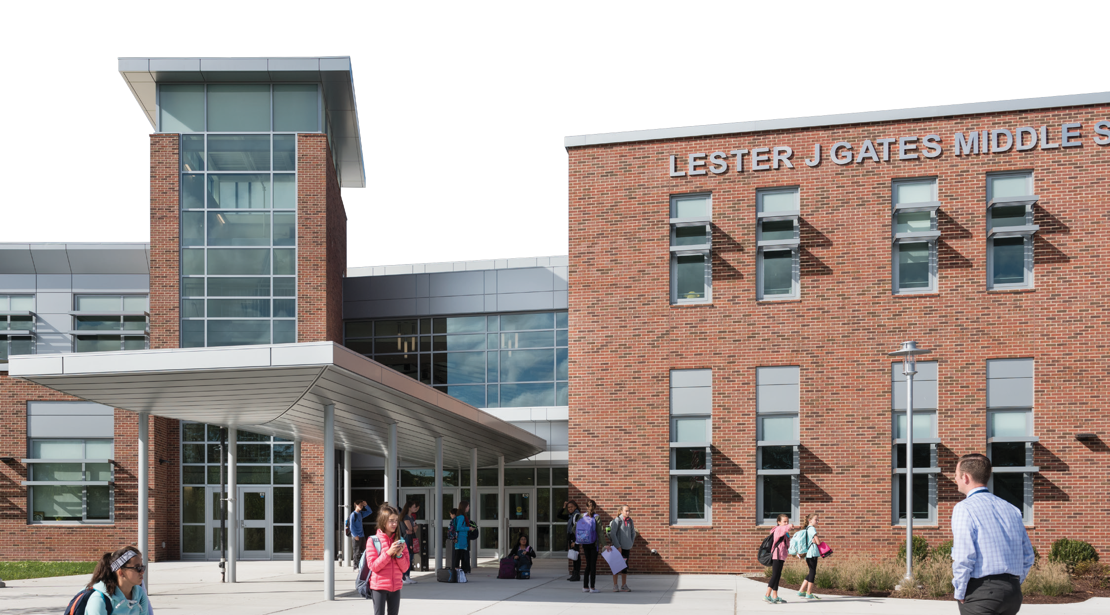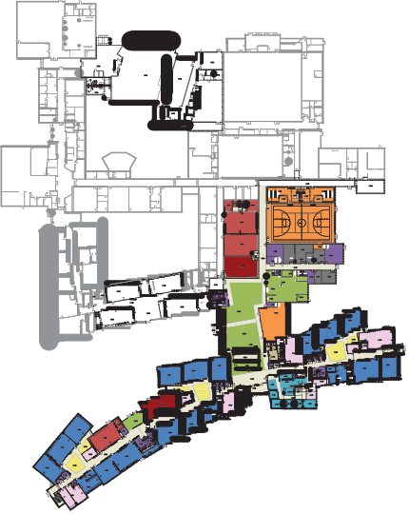

*Supporting the Curriculum*

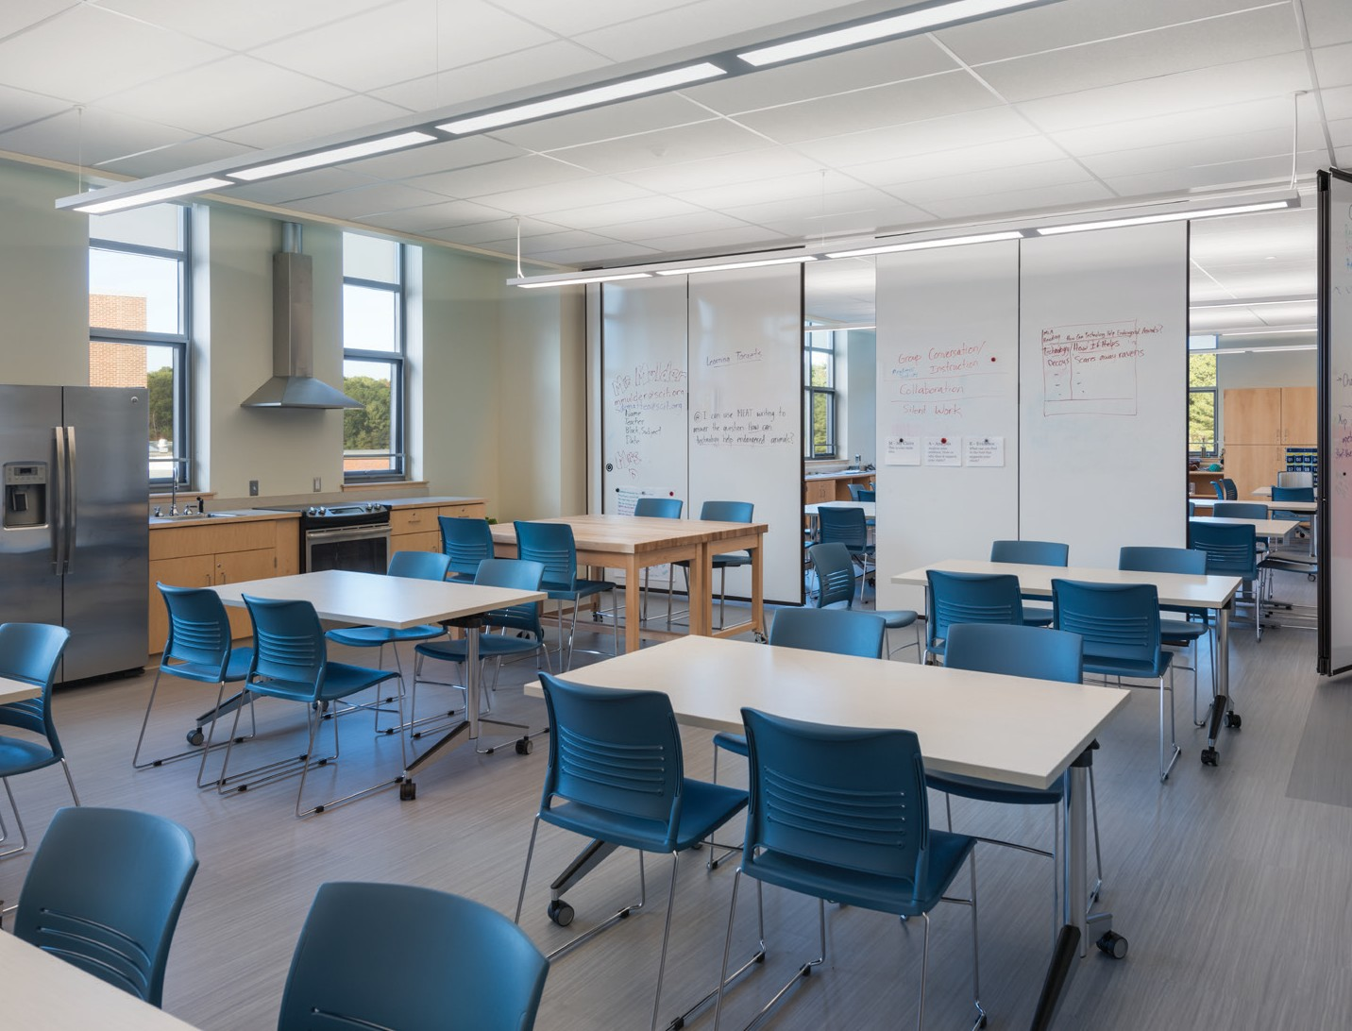

Scituate’s new vision for educational delivery focused on teachers working together to create authentic, project- based, and interdisciplinary lessons. Math teachers and science teachers collaborate on lessons that combine scientific observation and data gathering with graphing of data and searching for trends. English teachers and art teachers collaborate to illustrate children’s books. As a result, the composition of grade level teams and the individual features of the learning studios became critical.

FIRST FLOOR PLAN

**STAIR 1**

**S1-1**

**388 SF**

**904 SF**

**Custodial & Maintenance**

**MECHANICAL SYSTEMS:**

Displacement ventilation in classroom and learning spaces; air conditioning in administration and guidance.